WEEK 3 Progress

Jaison Lewis

------------------------------------------------------------------------------------------------------------------------

Programs made this week  
1: Synthetic Image generator: Python program makes 256x256 images with random circles, squares and triangles. The first version made overlapping objects of various sizes which would make it difficult to train. Since the object of this exercise was to see if the program could recognise the objects. I modified the program to generate images with either four, 9 or 16 quadrants and then generate the objects within the quadrants within the maximum size of the quadrant so they don’t overlap.

Generated Images:

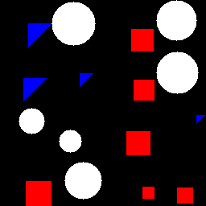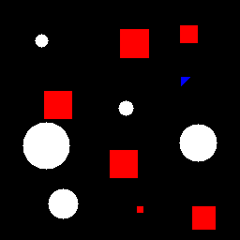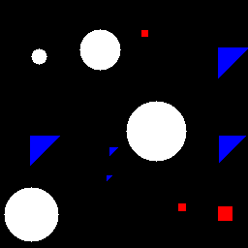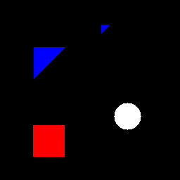

Image1 Image2 Image 3 Image 4

Generated Masks:

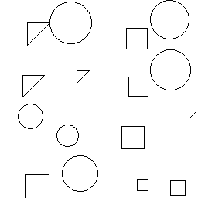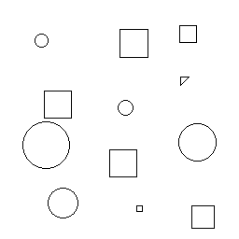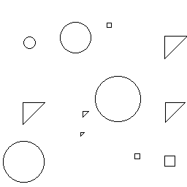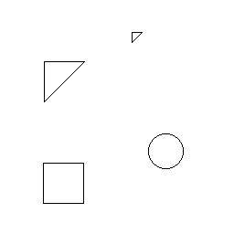

Mask1 Mask2 Mask3 Mask4

Code Link: <https://github.com/jaisonlewis/synthetic-test-data/blob/KidneyKaggleChallenge/synthetic-data-with-masks-csv.py>

2: Unet code adapted from Digital Sreeni: Took base code off Digital Sreeni and implemented model checkpoint and early stopping so it can use the best models and prevent overfitting. Did ten epochs using 2000 synthetic masks and images. The model was able to accurately predict mask with the 10epoch model. However, from the loss chart we can see there is more space for training.

Training and validation loss for synthetic data 10 Epochs:

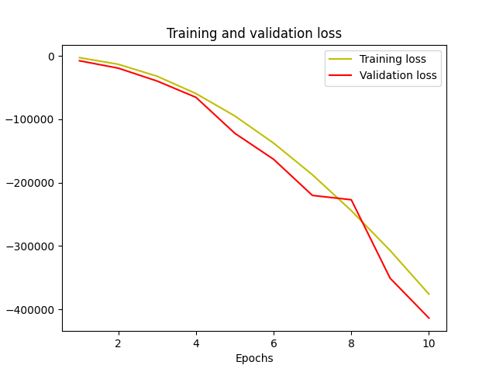

Ground truth check for synthetic data 10 Epochs:  
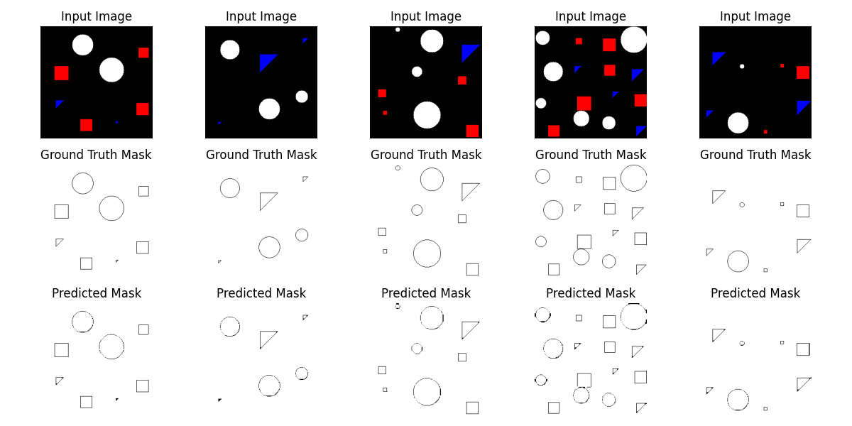

Code link: <https://github.com/jaisonlewis/unet-synthetic-data/blob/KidneyKaggleChallenge/unet-on-synthetic-data.py>

3: Segment every grain

Tested Synthetic data with segment every grain. Abandoned as it doesn’t detect the smaller objects, which means it will not work well with the kidney tissues. Code adapted from official ipynb file. You have to get the checkpoints to run it. ie: seg_model and sam_vit_h_4b8939.pth

Code: <https://github.com/jaisonlewis/Seg-every-grain-mod/blob/KidneyKaggleChallenge/Segment_every_grain.py>

Tried to adapt same model with kidney data with disappointing results. Code stopped midway to prevent overfitting. Only 4 epochs. So, I will make masks similar to the ones Sreeni uses which are black outline on white background.

Uploaded all existing code to Github.

Researched Mask-RCNN and Faster RCNN as a possible way to segment.